Best Programming Practice
- Use Variables including for Fixed, User Inputs, and Results
- Use Methods instead of writing code in the main() function
- Proper naming conventions for all variables and methods
- Proper Program Name and Class Name
- Handle Checked and Unchecked Exceptions wherever possible
- Proper Method Name which indicates action taking inputs and providing result
Sample Program 1: Create a program to find all the occurrences of a character in a string using charAt() method
- Take user input for the String and occurrences of the Character to find
- Write a method to find all the occurrences of the characters.
  - The logic used is to first find the number of occurrences of the character and
  - then create an array to store the indexes of the character
- Call the method in the main and display the result
// Program to find all the occurrences of a character in a string
import java.util.Scanner;
class StringAnalyzer {
// Method to find all the index of a character in a string using charAt()
// method and return them in an array
public static int[] findAllIndexes(String text, char ch) {
// The count is used to find the number of occurrences of the character
int count = 0;
for (int i = 0; i < text.length(); i++) {
if (text.charAt(i) == ch) {
count++;
}
}

// Create an array to store the indexes of the character
int[] indexes = new int[count];
int j = 0;
for (int i = 0; i < text.length(); i++) {
if (text.charAt(i) == ch) {
indexes[j] = i;
j++;
}
}
return indexes;
}
public static void main(String[] args) {
// Take user input for Text and Character to check Occurrences
Scanner sc = new Scanner(System.in);
System.out.print(Enter a text: ");
String text = sc.nextLine();
System.out.print("Enter a character to find the occurrences: ");
char ch = sc.next().charAt(0);

// Find the occurrences of the character
int[] indexes = findAllIndexes(text, ch);

// Display the occurrences of the character
System.out.println("Indexes of the character '" + ch + "': ");
for (int i = 0; i < indexes.length; i++) {
System.out.print(indexes[i] + " ");
}
}
}



Level 2 Practice Programs
- Write a program to find and return the length of a string without using the length() method
Hint =>
- Take user input using the Scanner next() method
- Create a method to find and return a string's length without using the built-in length() method. The logic for this is to use the infinite loop to count each character till the charAt() method throws a runtime exception, handles the exception, and then return the count
- The main function calls the user-defined method as well as the built-in length() method and displays the result
- Write a program to split the text into words, compare the result with the split() method and display the result
Hint =>
- Take user input using the Scanner nextLine() method
- Create a Method to find the length of the String without using the built-in length() method.
- Create a Method to split the text into words using the charAt() method without using the String built-in split() method and return the words. Use the following logic
  - Firstly Count the number of words in the text and create an array to store the indexes of the spaces for each word in a 1D array
  - Then Create an array to store the words and use the indexes to extract the words
- Create a method to compare the two String arrays and return a boolean
- The main function calls the user-defined method and the built-in split() method. Call the user defined method to compare the two string arrays and display the result
- Write a program to split the text into words and return the words along with their lengths in a 2D array
Hint =>
- Take user input using the Scanner nextLine() method
- Create a Method to split the text into words using the charAt() method without using the String built-in split() method and return the words.
- Create a method to find and return a string's length without using the length() method.
- Create a method to take the word array and return a 2D String array of the word and its corresponding length. Use String built-in function String.valueOf() to generate the String value for the number
- The main function calls the user-defined method and displays the result in a tabular format. During display make sure to convert the length value from String to Integer and then display
- Write a program to split the text into words and find the shortest and longest strings in a given text
Hint =>
- Take user input using the Scanner nextLine() method
- Create a Method to split the text into words using the charAt() method without using the String built-in split() method and return the words.
- Create a method to find and return a string's length without using the length() method.
- Create a method to take the word array and return a 2D String array of the word and its corresponding length. Use String built-in function String.valueOf() to generate the String value for the number
- Create a Method that takes the 2D array of word and corresponding length as parameters, find the shortest and longest string and return them in an 1D int array.
- The main function calls the user-defined methods and displays the result.
- Write a program to find vowels and consonants in a string and display the count of Vowels and Consonants in the string
Hint =>
- Create a method to check if the character is a vowel or consonant and return the result. The logic used here is as follows:
  - Convert the character to lowercase if it is an uppercase letter using the ASCII values of the characters
  - Check if the character is a vowel or consonant and return Vowel, Consonant, or Not a Letter
- Create a Method to Method to find vowels and consonants in a string using charAt() method and finally return the count of vowels and consonants in an array
- Finally, the main function takes user inputs, calls the user-defined methods, and displays the result.
- Write a program to find vowels and consonants in a string and display the character type - Vowel, Consonant, or Not a Letter
Hint =>
- Create a method to check if the character is a vowel or consonant and return the result. The logic used here is as follows:
  - Convert the character to lowercase if it is an uppercase letter using the ASCII values of the characters
  - Check if the character is a vowel or consonant and return Vowel, Consonant, or Not a Letter
- Create a Method to find vowels and consonants in a string using charAt() method and return the character and vowel or consonant in a 2D array
- Create a Method to display the 2D Array of Strings in a Tabular Format
- Finally, the main function takes user inputs, calls the user-defined methods, and displays the result.
- Write a program to trim the leading and trailing spaces from a string using the charAt() method
Hint =>
- Create a method to trim the leading and trailing spaces from a string using the charAt() method. Inside the method run a couple of loops to trim leading and trailing spaces and determine the starting and ending points with no spaces. Return the start point and end point in an array
- Write a method to create a substring from a string using the charAt() method with the string, start, and end index as the parameters
- Write a method to compare two strings using the charAt() method and return a boolean result
- The main function calls the user-defined trim and substring methods to get the text after trimming the leading and trailing spaces. Post that use the String built-in method trim() to trim spaces and compare the two strings. And finally display the result
- Write a program to take user input for the age of all 10 students in a class and check whether the student can vote depending on his/her age is greater or equal to 18.
Hint =>
- Create a method to define the random 2-digit age of several students provided as method parameters and return a 1D array of ages of n students
- Create a method that takes an array of age as a parameter and returns a 2D String array of age and a boolean true or false to indicate can and cannot vote. Inside the method firstly validate the age for a negative number, if a negative cannot vote. For valid age check for age is 18 or above to set true to indicate can vote.
- Create a method to display the 2D array in a tabular format.
- Finally, the main function takes user inputs, calls the user-defined methods, and displays the result.
- Rock-Paper-Scissors is a game played between a minimum of two players. Each player can choose either rock, paper, or scissors. Here the game is played between a user and a computer. Based on the rules, either a player or a computer will win. Show the stats of player and computer win in a tabular format across multiple games. Also, show the winning percentage between the player and the computer.
Hint =>
- The rule is: rock-scissors: rock will win (rock crushes scissors); rock-paper: paper wins (paper covers rock); scissors-paper: scissors win (scissors cuts paper)
- Create a Method to find the Computer Choice using the Math.random
- Create a Method to find the winner between the user and the computer
- Create a Method to find the average and percentage of wins for the user and the computer and return a String 2D array
- Create a Method to display the results of every game and also display the average and percentage wins
- In the main take user input for the number of games and call methods to display results
- Create a program to take input marks of students in 3 subjects physics, chemistry, and maths. Compute the percentage and then calculate the grade as shown in figure below
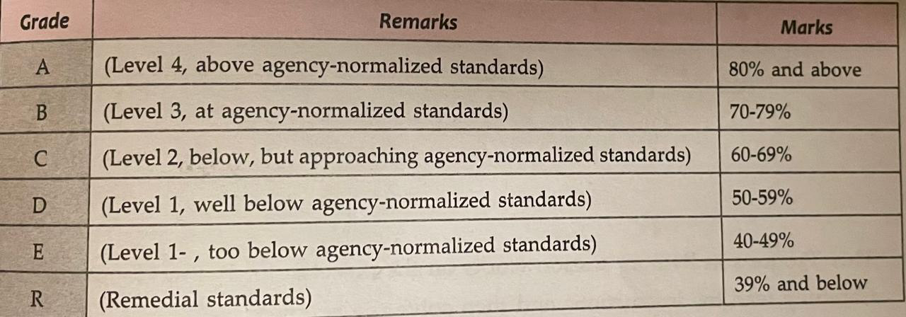
Hint =>
- Write a method to generate random 2-digit scores for Physics, Chemistry and Math (PCM) for the students and return the scores. This method returns a 2D array with PCM scores for all students
- Write a Method to calculate the total, average, and percentages for each student and return a 2D array with the corresponding values. Please ensure to round off the values to 2 Digits using Math.round() method
- Write a Method to calculate the grade based on the percentage as shown in the ref table and return a 2D array of students' grade
- Finally write a Method to display the scorecard of all students with their scores, total, average, percentage, and grade in a tabular format.

